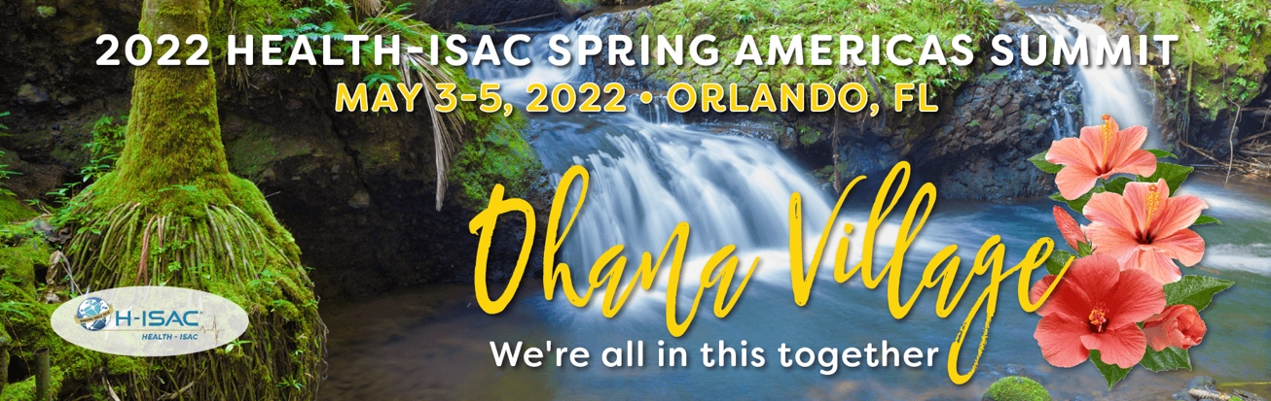

Dear <Insert Manager’s Name>,
I’d like to request your permission to attend H-ISAC's Ohana Village Summit which takes place May 3-5 at the Loews Royal Pacific in Orlando, FL.
The conference will give me a chance to connect with over 500 industry attendees and numerous sessions including: Transparency in Risk Documentation, Micro & Nano Segmentation in Cloud Native Design, and Evolving Your Program – Cyber-Physical Security Fusion.
The conference includes 5 general sessions and 35 breakout sessions, including a session on <insert desired session topics here>. All content will be available on-demand to registered attendees, meaning I can watch up to 22 hours of thought-leadership educational sessions. With such a wide range of information, attendees return to their roles with ideas to implement immediately.
It’s more important than ever to ensure we’re getting the most out of our education and training investment. The summit will allow me access to updated information from industry leaders and connections with sponsors and exhibitors that could enhance our performance here at <insert company here>
The approximate cost (USD) of my attendance at H-ISAC’s Ohana Village Summit from Tuesday, May 3 to Thursday, May 5 is below:
Conference Rate: $149 Members / $299 Non-Members (In-Person)
$199 Members / $349 Non-Members (Virtual)
Hotel (3 nights at $235/night plus tax): $793 (including tax)
Parking (3 nights $12/night plus tax): $40 (including tax, if applicable)
Airfare: $450 (estimated, if applicable)
Airport Transportation: $40 (Uber)
Internet Access: $0 (complimentary)
Total Cost: <insert sum of cost here>

H-ISAC and the Loews Royal Pacific are committed to ensuring the health and well-being of our attendees and staff at our events. In addition to the Resort’s protocols, H-ISAC will follow all local public health agency guidelines.
H-ISAC has negotiated a discounted rate single/double of $235/night (plus tax) at Loews Royal Pacific if I book my hotel on or before April 11th. Therefore, I do appreciate your immediate attention to my request.
Additional information about H-ISAC’s Ohana Village Summit is available at:
https://h-isac.org/summits/spring-2022-summit-2/
Thank you for your consideration.
Regards,

